

SIMATS ENGINEERING

Saveetha Institute of Medical and Technical Sciences
Chennai- 602105

Student Name: A. Reddy Prasad Reg. No.: 192472045
Course Code: DSA0405 Slot: D
Course Name: Fundamentals of data science
Course Faculty: Dr. Krishna raj Mony
Project Title: Exploratory Statistical Analysis of Clinical and Lifestyle Indicators for Early Health Risk
Module Photographs:
Architecture Diagram | Module1: Data Cleaning & Preprocessing | Presentation Image
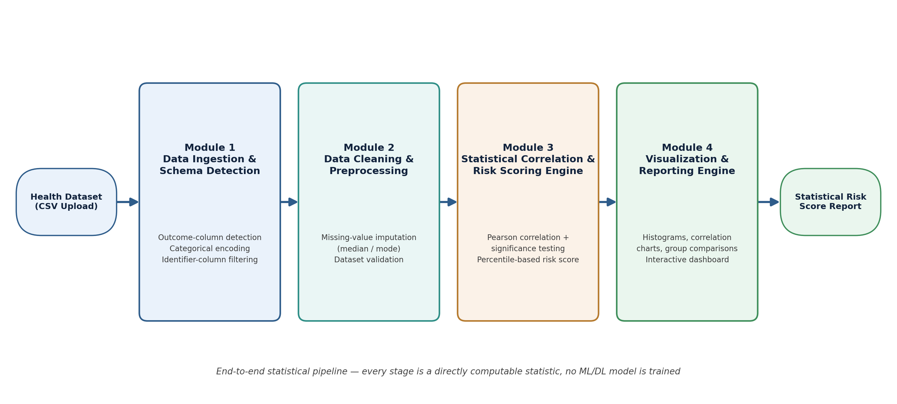 | 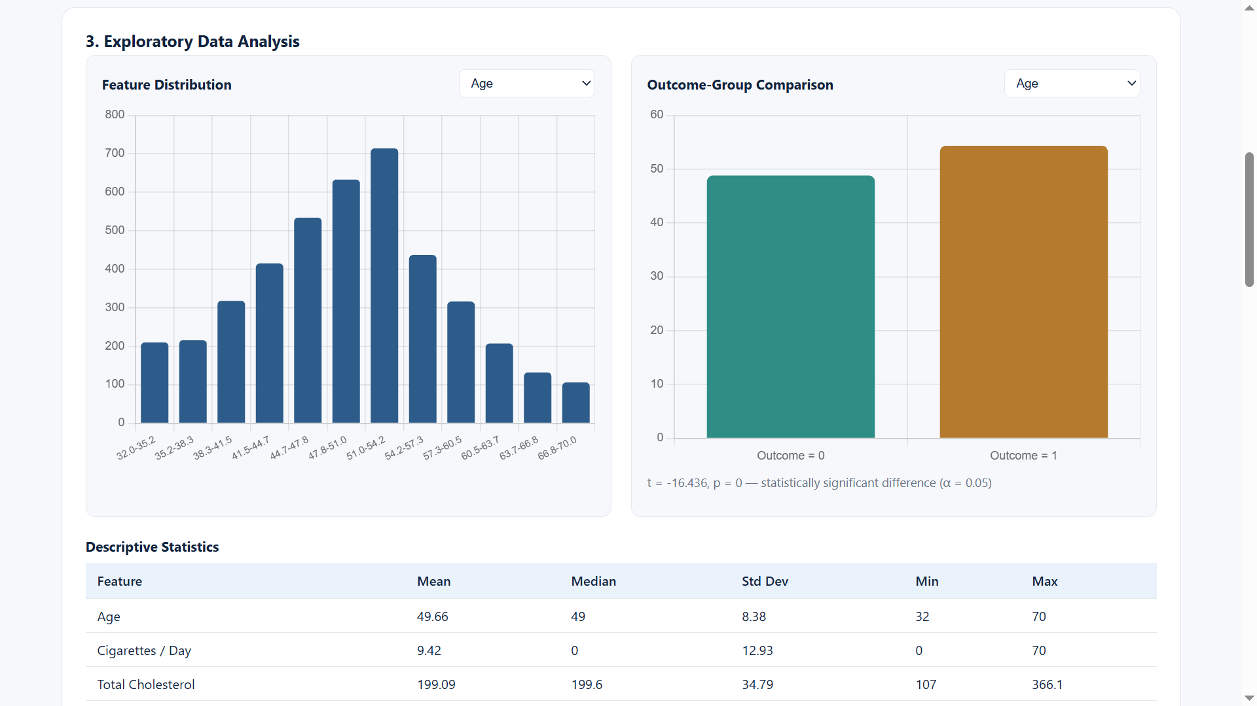 | 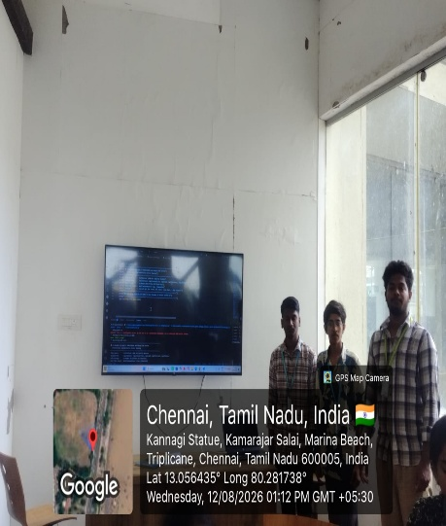
Project Description:
Exploratory Statistical Analysis of Clinical and Lifestyle Indicators for Early Health Risk focuses on analyzing health-related clinical and lifestyle data to identify factors that may contribute to early health risks. The project examines variables such as age, gender, BMI, blood pressure, cholesterol level, glucose level, smoking habits, alcohol consumption, physical activity, sleep duration, and dietary habits.
Statistical methods such as descriptive statistics, correlation analysis, hypothesis testing, probability distributions, regression analysis, and data visualization are used to understand relationships between different health indicators. The project can identify significant risk factors and detect patterns among individuals with different health conditions.

Student Signature Guide Signature

